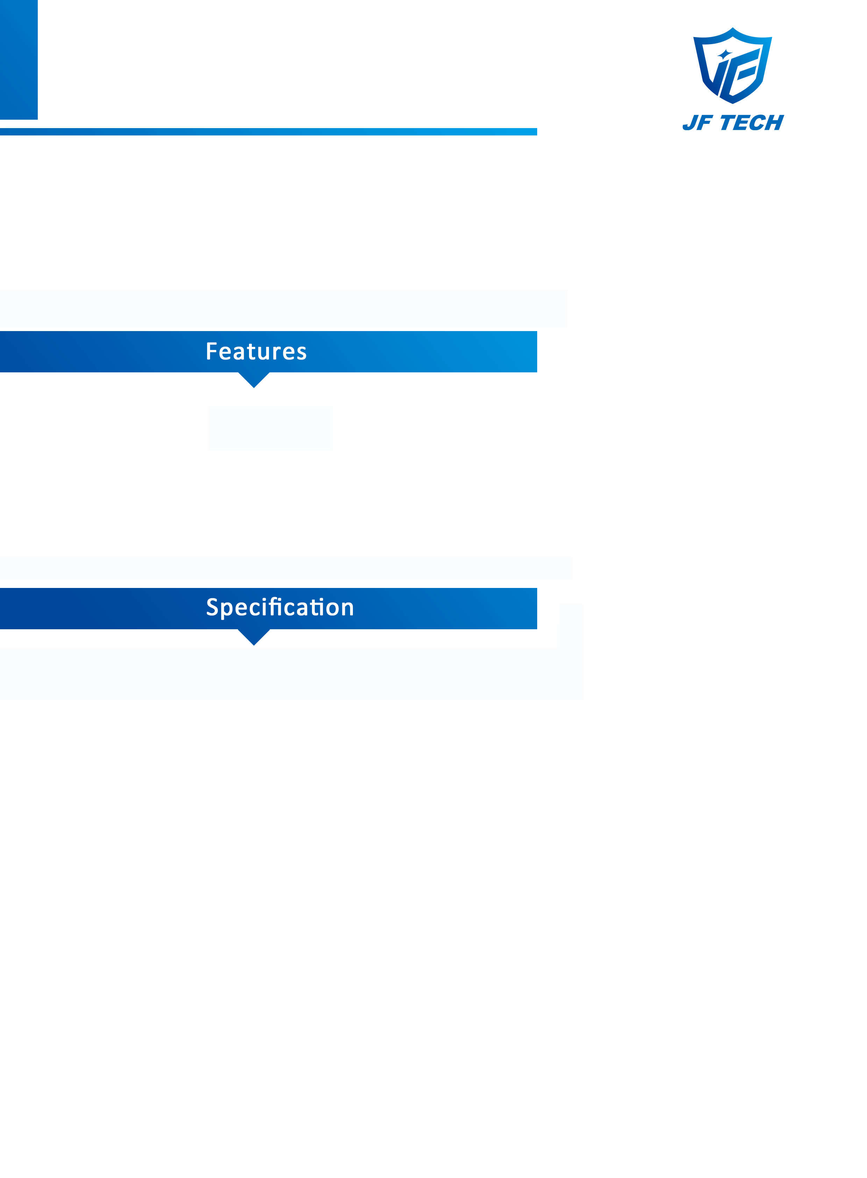

JF-SD-FN5240M-X18R

4MP Network IR PTZ Camera

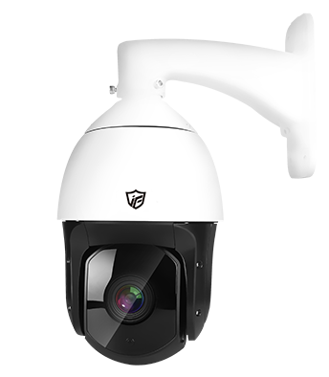





◆ 4MP@25fps

◆ HD lens: 4.7~84.6mm(18x Optical zoom)

◆ Support ONVIF(profile S)

◆ Support H.265 video compressions,

multi-level video quality configuration

◆ Protection level is IP66

◆ Supporting WEB, VMS, MYEYE platform;

◆ Support mobile phone monitoring

(IOS, Android);

◆ 360°endless pan range and -10°~90°tilt range

◆ PTZ functions：Up to 80 presets, up to 1

auto scan, up to 4 tour, up to 1 pattern

|  |  |
| --- | --- |
| **Camera** | |
| Model | JF-SD-FN5240M-X18R |
| Image Sensor | 1/3'' 4MP CMOS |
| Size | 5'' |
| Min.illumination | 0.01Lux@F1.2(Color)/0.001Lux@F1.2(B/W) |
| Lens | 4.7~84.6mm(18x Optical zoom) |
| Day/Night | IR CUT |
| Wide Dynamic Range | DWDR |
| Max.IR Distance | 120m |
| Video Compression | H.265 |
| Multi-streaming | Dual-stream |
| Frame Rate | 4MP@25fps |
| Pan/Tilt | Pan:0°~360°endless;Tilt:-10°~90° |
| Intelligent Video | -- |
| Compatibility | ONVIF |
| **Interface** | |
| Audio In/Out | -- |
| Memory Slot | SD,Max 128G |
| Alarm In/Out | -- |
| **General** | |
| Ingress Protection | IP66 |
| Working Temperature | -20℃~+65℃ |
| Power | DC12V±10%,PoE |

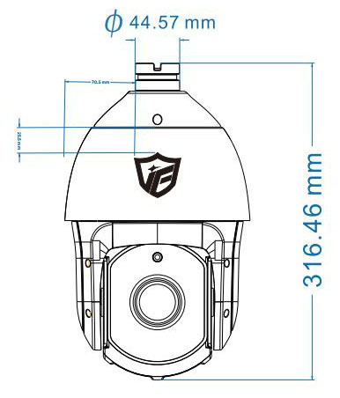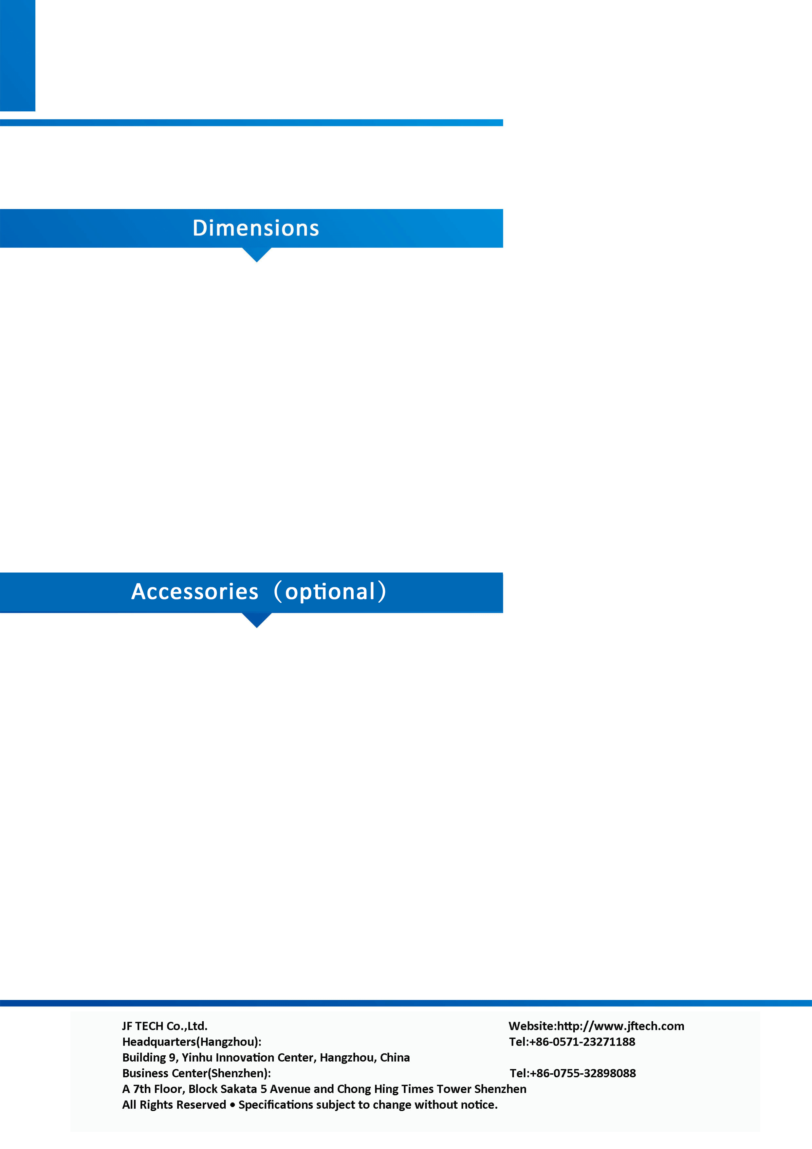

JF-SD-FN5240M-X18R

4MP Network IR PTZ Camera